Scripts for Scene: **OutsideBuilding**

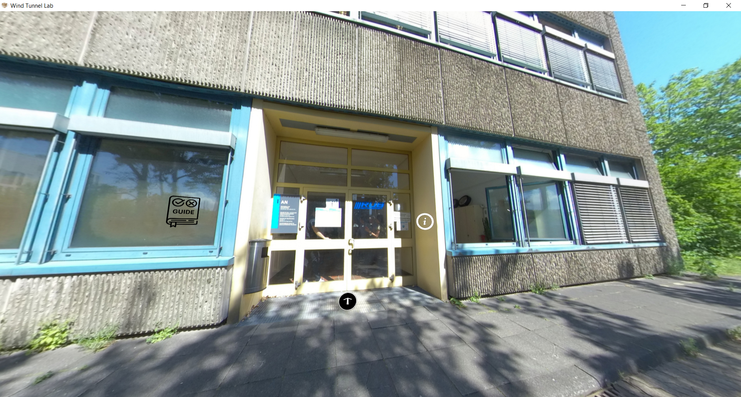

|  |  |  |
| --- | --- | --- |
| Nr | Hotspot (see red arrow) | Script |
| 1 | Hotspot: Welcome text | Script only:  Welcome to the Atmospheric Boundary Layer Wind Tunnel of WISt-RUB, Chair of Wind Engineering and Fluid Dynamics of Ruhr-Universität Bochum. Today, we will take you to a tour of the wind tunnel. |
| 2 | Hotspot: Website WIST | Script only:  Website:  <https://www.ruhr-uni-bochum.de/wist/> |
| 3 | Hotspot: “Let’s go!” | No script just title of the hotspot “Let’s go!” |